ARKANSAS COMMUNITY AND ECONOMIC
DEVELOPMENT PROGRAM (ACEDP)
Community Development Block Grant Program (CDBG)
State Program for Small Cities



General Assistance Application
Effective for 2025 Program Year (July 1, 2025 through June 30, 2026)

This is an electronically controlled document. The electronic version on the AEDC-Grants website is the most recent version, and is the only official version, of the document. Revisions are made periodically. The version date is shown in the footer of each page of the document. If the user is consulting a version with a version date differing from the version date of the official version on the website, then changes have been made. Refer to the table of revision changes online.
AEDC does not discriminate on the basis of Race, Color, National Origin, Sex, Age, Religion or Disability; and provides upon request, reasonable accommodation including auxiliary aids and services necessary to afford an individual with a disability an equal opportunity to participate in all programs and activities.

Table of Contents

Section 1. OVERVIEW
Overview 3
- Eligible Applicants 4
- Eligible Activities 4
- Ineligible Activities 4
- Grant Amounts, Matching Funds & Leverage 5
- Application Due Dates 5
- Threshold Review Criteria 6
- CDBG National Objective 6
- Post Award Requirements 6
- Application Point System and Scoring 6

Section 2. APPLICATION FORMS & INSTRUCTIONS
Application Forms & Instructions 8
Table of Contents Checklist 10
Part I. General Information 12
Part II. Project Budget 15
Part III. Project Description & Scoring Criteria 17
Part IV. Exhibits and Attachments 29

Section 1 Overview
These application guidelines are for all General Assistance applications. Any eligible applicant must follow the instructions and information within this Application Package in order to apply for General Assistance resources.

To assist with application development, the Grants Division of the Arkansas Economic Development
Commission has prepared ACEDP Application Guidelines (the Guidelines) as an application reference source. These most up-to-date version of these guidelines can be found online. To request a copy of the Guidelines or to obtain assistance regarding application requirements, please contact the Grants Division at (501) 682-1211.

Most funding determinations will be made within 90 days from the close of the application period. However, if the application is incomplete, additional information may be requested prior to the approval of the application. A completed application will consist of all documents enumerated in the Application Table of Contents. Only one copy of the application is required.

The General Assistance line item is designed to provide Arkansas’s non-entitlement cities and counties with the opportunity to apply for grant assistance for a variety of projects that are not covered under other funding categories. Applicants may apply for assistance for any eligible project that meets the following criteria:

- The project must meet one of the national objectives of the Community Development Block Grant (CDBG) program: benefit to low- to moderate-income persons, elimination of conditions of slum or blight, or to address an urgent need.
- The activity to be undertaken is an eligible activity under the regulations that govern the CDBG program.
- The project must address one of the goals and objectives described in the current Consolidated Plan.
- The project must not be eligible for funding under any of the other line items in the current One Year Action Plan.

Funding will generally be provided for public infrastructure and public facility projects.

FOR MORE INFORMATION

For further information please contact the following Primary Contact for this program. See also the 2025-2026 ACEDP Application Guidelines and 2025-2026 ACEDP Exhibits.

Jean Noble
Director, Grants Division
Arkansas Economic Development Commission
1 Commerce Way, Suite 601
Little Rock, AR 72202
Phone: (501) 682-7389 or (888) 787-2527
Fax: (501) 682-7499
E-mail: jnoble@arkansasedc.com
http://www.arkansasedc.com/grants

- Eligible Applicants
Eligible applicants include all Arkansas cities and counties except for 14 entitlement cities” which receive their own funds directly from HUD.
Entitlement cities include:

- Bentonville
- Conway
- Fayetteville
- Fort Smith
- Hot Springs
- Jacksonville
- Jonesboro
- Little Rock
- North Little Rock
- Pine Bluff
- Rogers
- Springdale
- Texarkana, and
- West Memphis

- Eligible Activities
The following activities are eligible within the General Assistance Program. If any activity is not noted within the list below, please consult a member of the AEDC Grants Division in order to determine if any other proposed activities are eligible for the program.
- senior centers;
- child care centers;
- local county health units, or other local public health clinics;
- homeless shelters (excludes costs for operation);
- accredited public libraries;
- battered spouse shelters;
- centers for developmentally disabled adults;
- youth centers;
- food pantries;
- fire and/or rescue buildings, including fire trucks and fire equipment (communities over 3,000; communities under 3,000 should apply through the Rural Services Block Grant);
- removal of architectural barriers from city hall or county courthouses for accessibility;
- street, curb, gutter, or sidewalks, or storm sewer;
- flood control and drainage;
- tornado shelters, including in manufactured home parks;
- residential water and wastewater (must use Water/Wastewater application)

For more information see Section C of the Application Guidelines.
- Ineligible Activities
The following activities are ineligible within the General Assistance Program. If any activity is not noted within the list below, and is not listed as an eligible activity, please consult a member of the AEDC Grants Division in order to determine if any other proposed activities are eligible for the program.
- Buildings used predominantly for the general conduct of government such as:
  - City and halls (except for removal of architectural barriers only, see above);
  - County administrative buildings
  - State Capitols,
  - Office buildings or other facilities in which the legislative or general administrative affairs of the government are conducted.
- General government expenses, except those costs that are directly attributable to the administration of a local CDBG program;
- Facilities or equipment used for political purposes or to engage in other political activities;
- Purchase of equipment except as set forth in Section 1:L of the Application Guidelines;
- Generally, any expense associated with repairing, operating, or maintaining public facilities, improvements and services. For specific exceptions see Section 1:D of the Application Guidelines;
- For income payments for housing including:
  - Payments for income maintenance;
  - Housing allowances;
  - Down payments;
  - Mortgage subsidies.

For a full description of ineligible General Assistance activities, please see Section D of the Application Guidelines.
D. Grant Amounts, Matching Funds, & Leverage
Grant Amount: Grant requests should range from a minimum of $75,000 to a maximum of $500,000, including design fees. Water or wastewater applicants may apply for up to $1,000,000 for construction of new systems or extension of new service to existing systems, where new customers are added. Administrative fees will be added to the announced award amount.

Total awards for all grants, including administrative fees, will not exceed the announced line item amount.
Match Requirements: There is no match required.

Leverage: Leverage includes funds that are committed to the project activities exceeding the grant dollars requested through AEDC. Leverage may include public and private funds, or in-kind services, such as materials, labor, or other items that are directly related to the project. Leveraged funds may be considered only if they are spent during the project period (date of Release of Funds through the project completion date). The amount of leverage must be given in dollars.
E. Application Due Dates
Applications are prepared at the applicants’ expense and costs are not reimbursable. General Assistance applications will be accepted by the AEDC Grants Division from July 1, 2025 through October 17, 2025. Applications will be accepted during this period based on U.S. Postal Service postmark date or date of delivery by other means (emails are accepted).
Applications are reviewed by the AEDC application review team according to the selection criteria established in Section 2, Application Forms and Instructions, Part III: Project Description and Scoring Criteria of this document. All grants must have an AEDC-“certified” grant administrator. Projects are generally expected to be completed by the grantees within 24 months following award. NOTE: All land or property for the project MUST be in the possession of the community, or in an option to acquire, at the time of application.
F. Threshold Review Criteria
The following threshold requirements must be met by the local government applicant in order to be eligible for Program resources. These requirements include:

  - Activities proposed are eligible and comply with CDBG National Objectives and State CDBG priorities. See the CDBG National Objective Section for more information.
  - applicant has no significant, unresolved audit finding;
  - applicant has no legal actions under way that may significantly impact its capacity;
  - applicant is following a detailed Citizen Participation Plan (CPP) and Anti-Displacement Plan;
  - applicant has adopted an authorizing participation resolution;
  - applicant must have addressed and cleared all compliance problems (i.e. Davis Bacon, acquisition, fair housing, etc.) found during monitoring, if any, from past awarded projects, and have had a response accepted by AEDC;
  - applicant is current with all reporting requirements (semiannual status reports, closeout reports, audit reports, notification of annual audits, etc.); and
  - A city applicant does not have any other open categorical grants, and a county does not have more than one other open categorical grants. Check with AEDC Grants Division for grant status.

G. CDBG National Objective
All General Assistance projects funded, and CDBG-funded project activities, must meet a National Objective of the CDBG Program. This includes:

- Benefiting low-to-moderate income persons (LMI); (including on an area basis or serving a limited clientele);
- Elimination of conditions of slum or blight, or,
- Address an urgent need.

For more information see Section 1:A of the Application Guidelines.

A project or project activity that fails to meet one of these specified national objectives is ineligible for CDBG resources.

H. Post Award Requirements
Each eligible application must also comply with any necessary post award requirements. These requirements include: Environmental Review; Davis-Bacon compliance; Procurement, etc.

For more information, and for a complete list of Post Award Requirements, see Section 1:U of the Application Guidelines.

I. Application Point System and Scoring
The Method of Distribution section of the Application Guidelines contains specific information regarding the scoring criteria for each Program. A summary of the scoring criteria is noted within each Program’s Selection Criteria Matrix. For General Assistance applications, Section 2, Application Forms and Instructions, Part III: Project Description and Scoring Criteria, provides details on scoring and the points assigned to all scoring criteria.
Below is the Scoring Criteria Matrix for the General Assistance Program. The Matrix describes each selection criteria as a numerical score within the General Assistance Program. The maximum number of points available within any application is 100 points.

(1) | (2) | (3) | (4) | (5) | (6) | (7)
Project Need | Project Specs | Project Readiness | Citizen Participation | Funding  Leverage | LMI  Benefit | Bonus Points | TOTAL
30 | 10 | 30 | 15 | 5 | 5 | 5 | 100 points

Section 2 Application Forms & Instructions
This section contains all forms and exhibits to be submitted so that your application can be scored and ranked effectively. Application narratives should be thorough and concise. The Grants Division reserves the right to verify all information, and to consult with other agencies on the proposed project.

There are more applicants requesting funds than there are funds available. Applicants must carefully read and review the Application Guidelines and the selection criteria described to develop a competitive application.

In submitting your application, these instructions must be followed:

- Submit ORIGINAL, ONE (1) complete copy by mail, email, or file sharing service

- Do not fold, staple, or bind in any way other than with a binder clip or rubber band (no binders, binding, or heavy stapling)

- Table of Contents must be included

- All pages must be numbered in sequence at the bottom of the page.

- All Exhibits must be labeled at the bottom of the page, right-hand corner.

- All Attachments must be labeled at the bottom of the page, right-hand corner.

Failure to follow these instructions may result in your application being returned for you to correct and resubmit. All applicants will be given one week to correct and resubmit their application, if submitted at least two weeks in advance of the deadline.

Below is an outline of what a General Assistance Application should look like:
Part I. General Information (found at www.arkansasedc.com/grants) – This should be used as cover sheet
Table of Contents (use Table of Contents Checklist)
Part II. Project Budget (use required form)
Part III. Project Description & Scoring Criteria
Part IV. Required Exhibits and Attachments (see Exhibits package)
Part V. Additional Attachments (supplemental info provided by applicant)

Table of Contents & Checklist

Each applicant must attach a Table of Contents to their application and must include a Table of Contents Checklist for the Program they are applying for with their application.

The following page provides the format for the Table of Contents Checklist for General Assistance applications.

Table of contents checklist
general ASSISTANCE

Applicants must complete and submit this checklist with the application. Type in additional appendix items as deemed necessary to your project. List appropriate page numbers under PAGE NUMBER column.

PROJECT INFORMATION PAGE NUMBER

Part I – General Information (this 3-page Application should act as the Cover Page)

Table of Contents

Part II Project Budget

Part III Item 1 – Project Need

Part III Item 2 – Project Specifications

Part III Item 3 – Project Readiness

Part III Item 4 – Citizen Participation

Part III Item 5 – Leverage

Part III Item 6 – LMI Benefit

Part III Item 7 – Bonus Points

Part IV - REQUIRED EXHIBITS AND ATTACHMENTS

A. Notice of Public Hearing and Public Hearing Documentation

B. Authorizing Resolution

C. Statement of Assurances and Certifications

D. Citizen Participation Plan

E. Residential Anti-displacement & Relocation Assistance Plan

F. Excessive Force Resolution

G-1. Low- and Moderate-Income Worksheet (Only for LMI Area benefit surveys)

G-2. LMI Random Sample Worksheet (Only for LMI Area Benefit)

H. Limited Clientele Worksheet (Only for LMC)

I-1. Slum and Blight Area Basis Documentation (Only for SBA Area Basis)

I-2. Slum and Blight Spot Basis Documentation (Only for SBA Spot Basis)

J. Urgent Need Certification (Only for Urgent Need)

K. Federal Funding Accountability and Transparency Act (FFATA) form

L. Map of Proposed Project Area

M. Systems for Award Management (SAM) record and clearance documentation

N-1. Four Factor Analysis Assessing Limited English Proficiency

N-2. Language Assistance Plan (optional)

Please use the language verbatim in each exhibit. Incorrect language may cause a delay in application review and award, if successful. Also, provide the bracketed information as requested in each exhibit. The omission or incomplete description as requested in bracketed text may cause a delay in application review and awards.

REQUIRED ATTACHMENTS (where applicable)

Attachment 1. Facility Floor Plan (for all building projects)

Attachment 2: Documentation of Facility Ownership (for all building projects)

Attachment 3: Cost estimates for all costs listed in Part II, Project Budget

Attachment 4. Commitment letters for all sources listed in Part II, Project Budget

Part V - ADDITIONAL ATTACHMENTS (where available)

Attachment (number and title)

Attachment (number and title)

Attachment (number and title)

Attachment (number and title)

PART I. General Information
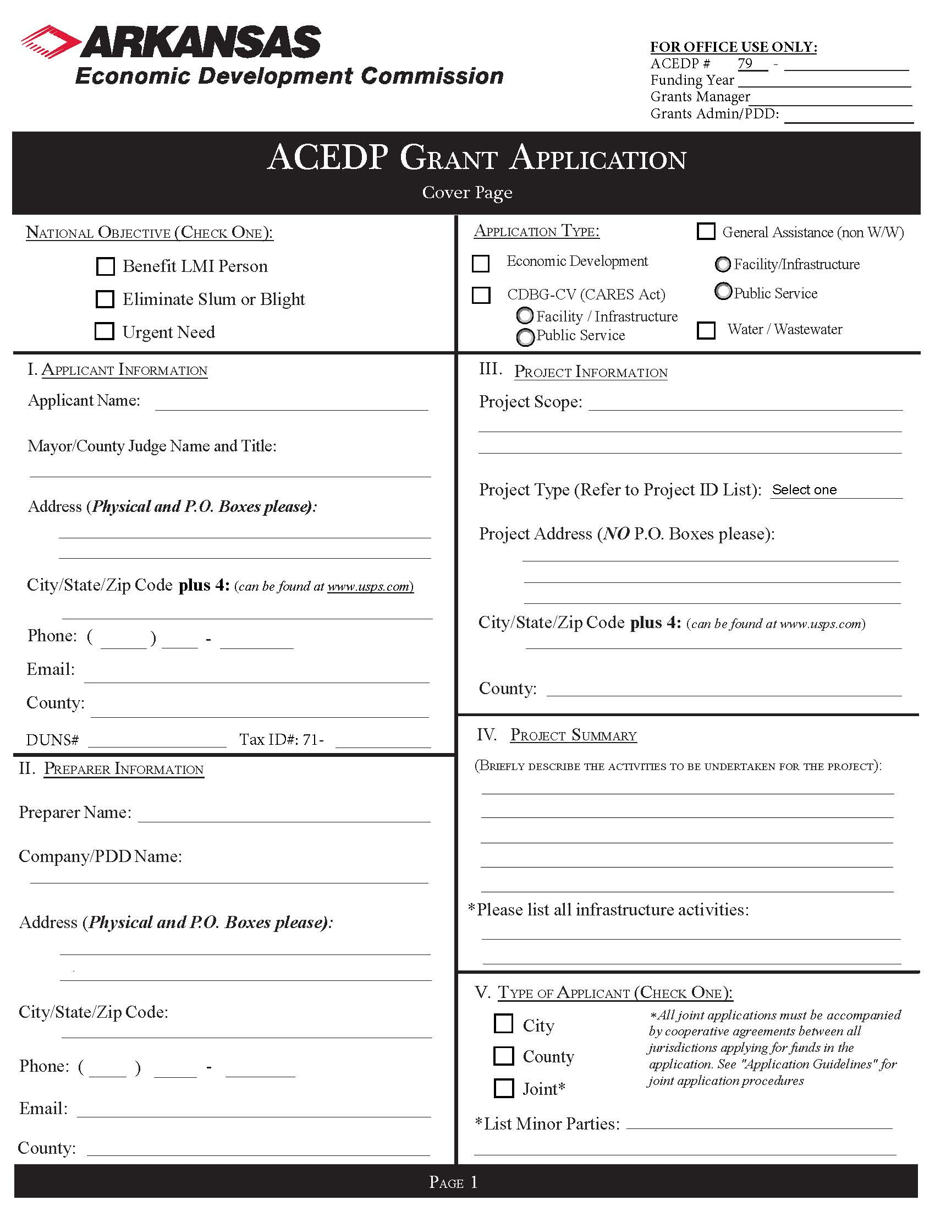

See Part I, General Information
.pdf form online and insert here

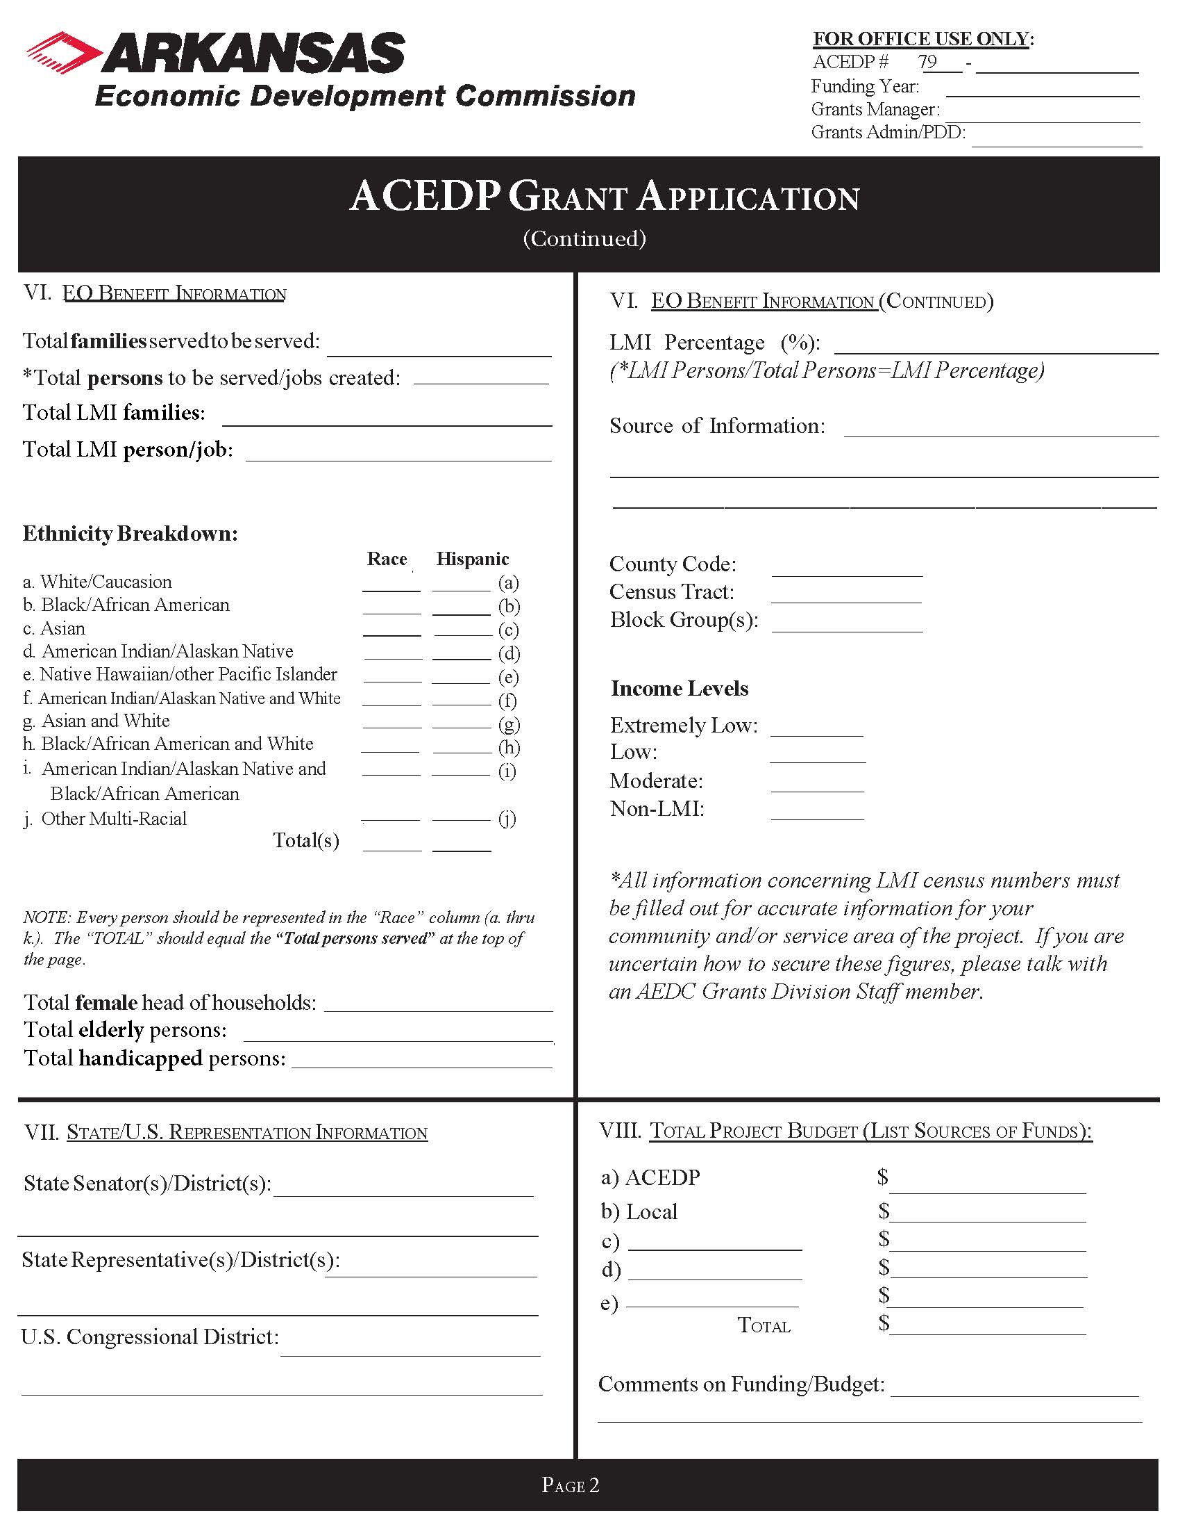

See Part I, General Information
.pdf form online and insert here

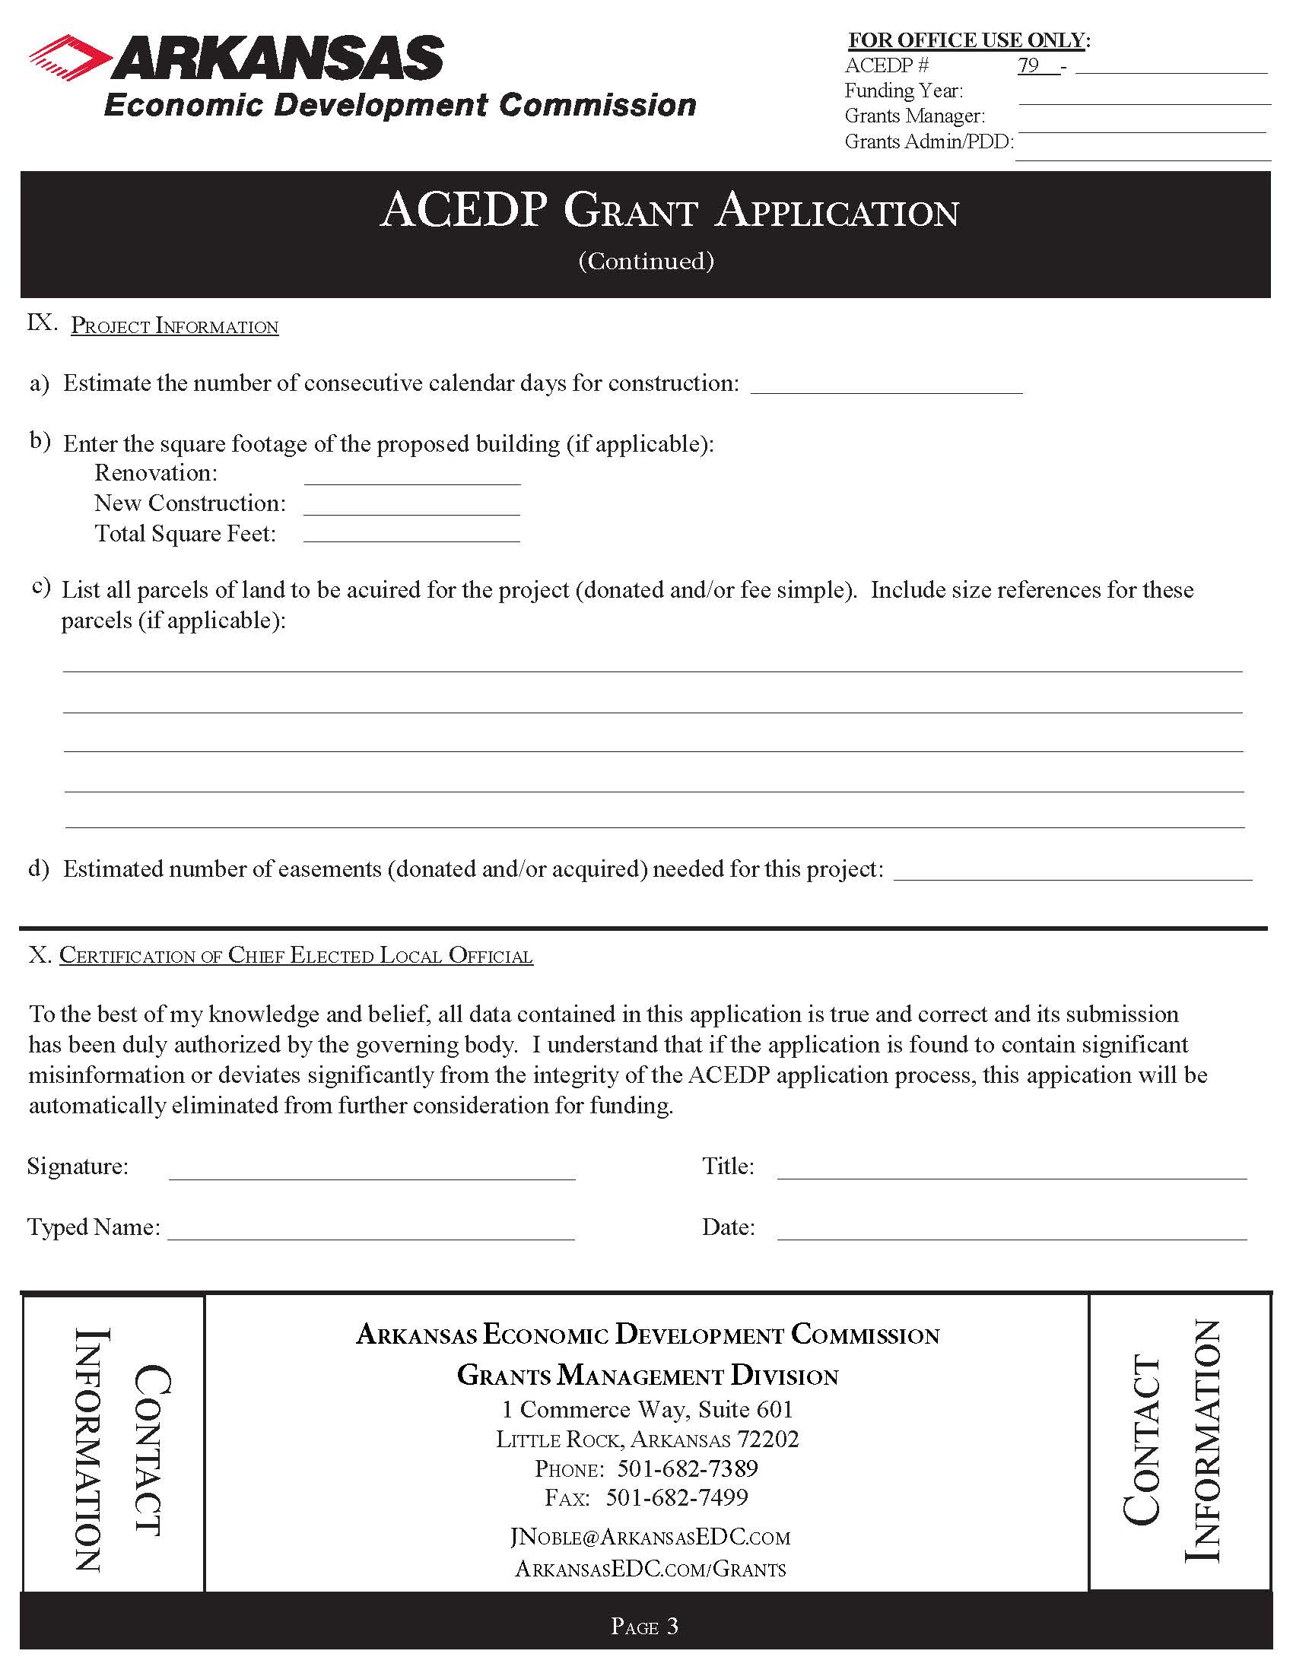

See Part I, General Information
.pdf form online and insert here
Part II. Project Budget

Applicant:
Funding Year: | Grant Year: | ACEDP Grant Control # :

Description |  | IDIS # |  | Other Funding Sources
Cost Classifications |  |  | CDBG | Local Cash |  |  | Total
Acquisition (attach itemized list) |  |  |  |  |  |  | $ 0.00
Land |  |  |  |  |  |  | $ 0.00
Abstractor |  |  |  |  |  |  | $ 0.00
Appraiser |  |  |  |  |  |  | $ 0.00
Legal |  |  |  |  |  |  | $ 0.00
Survey |  |  |  |  |  |  | $ 0.00
Architectural/Engineering: Basic Fee |  |  |  |  |  |  | $ 0.00
Inspection |  |  |  |  |  |  | $ 0.00
Additional Services (attach list) |  |  |  |  |  |  | $ 0.00
Construction |  |  |  |  |  |  | $ 0.00
Construction Contingency (maximum of 5%) |  |  |  |  |  |  | $ 0.00
Equipment |  |  |  |  |  |  | $ 0.00
LMI Hookups |  |  |  |  |  |  | $ 0.00
M & O |  |  |  |  |  |  | $ 0.00
Other |  |  |  |  |  |  | $ 0.00
Fees |  |  |  |  |  |  | $ 0.00
Permits |  |  |  |  |  |  | $ 0.00
Testing |  |  |  |  |  |  | $ 0.00
Other (specify__________________________) |  |  |  |  |  |  | $ 0.00
 |  |  |  |  |  |  | $ 0.00
 |  |  |  |  |  |  | $ 0.00
 |  |  |  |  |  |  | $ 0.00
Total |  |  | 0.00 | 0.00 | 0.00 | 0.00 | $ 0.00

Part II INSTRUCTIONS
FOR COMPLETING THE PROPOSED BUDGET

FOR ACEDP PROJECTS

Although some costs may not be definite at the time of budget preparation, it is important that the Proposed ACEDP Application Budget contains comprehensive, up-to-date cost estimates. These estimates can then be used to negotiate final budget amounts.

Project Information

Enter the name of the City or County as Applicant.

Cost Classifications Guidance

If ACEDP funds are requested for professional design services, the following fee scales must be utilized:
• Engineering costs must be in accordance with the USDA-RD engineering service fee schedule.
• Architectural costs must be in accordance with the State Building Services fee schedule.
If needed, these scales can be requested from the Commission at 682-1211.

Detailed explanation and justification, including calculation of cost, must be provided for any additional engineering services requested. Usually, no additional services will be approved.

Local cash contributions to the project must be the first construction dollars spent and will be incorporated as a requirement in any grant agreement executed by the applicant and the Commission.

Contingency funds may be Construction Contingency funds only, and are limited to 5% of the total construction cost

Any funds requested for "Other" must include a discussion of the requested service, including justification and cost calculations.

All acquisition costs must be accompanied by a brief discussion of each service to be provided and justification of the necessity of the services, including cost estimates. Each acquisition cost must indicate the unit rate and estimated number of units.

No ACEDP funds shall be used for Legal Services except for condemnation.

Do not include administrative costs on this budget estimate, unless other sources of funding will be paying in full for these services. Otherwise, these costs will be calculated by the Commission and added to the grant budget.

PART III. Project Description & Scoring Criteria
The Matrix below describes each selection criteria as a numerical score within the General Assistance Program. The maximum number of points available within any application is 100 points. All selection criteria will be scored in five-point increments and shall be scored on a scale.

(1) | (2) | (3) | (4) | (5) | (6) | (7)
Project Need | Project Specs | Project Readiness | Citizen Participation | Leverage | LMI  Benefit | Bonus Points | TOTAL
30 | 10 | 30 | 15 | 5 | 5 | 5 | 100 points

Limit responses to the space provided below with a minimum 9-point font (Arial or Calibri). For each of the following sections a project narrative must be provided and any additional information as noted within each individual application question.
Item 1: PROJECT NEED: Up to 30 points possible. The level of project need will be compared to other applicants.

Points in this section include:

0-9 points—no clearly defined problem or no clear description of the need for the project.

10-19—minor problems or minor need are only defined.

20-30—major problems or description of project need is clearly defined.

Some examples of major needs include:
- A public facility that is undersized or lacking space;
- The facility is not physically accessible/removal of architectural barriers;
- There is no similar facility or service within a reasonable distance;
- Construction or renovation of facilities that serve special-needs populations;
- Significant structural problems within a public facility or utility;
- There is a health and safety threat to users.

The application narrative shall be scored for: (a) explanations of the overall purpose of the project application and factual information that illustrates the severity of the problems or needs; (b) past efforts to resolve the problem and meet the local needs; and (c) stated goals and objectives for resolving the problem or need with a description of how the community will be included in the citizen participation process in order to determine the objectives for problem resolution.

Item 2: PROJECT SPECIFICATIONS: 10 points maximum possible. Describe the technical and financial specifications of the project and provide clarity on how the project will benefit those identified by a CDBG National Objective. The significance of the project specifications will be scored as compared to other applicants.

Points in this section include:

0-2 points—inadequately defined project specifications.

3-5—reasonably defined specifications that is average compared to other applicants.

6-10—above average description of project specifications. All requested data provided.

Within this section, the applicant should explain the technical and financial aspects of the project. Projects should have a clear outline of activities, state who will be responsible for each activity, state the frequency of usage, and a detailed explanation of how the project will reduce future need.

Item 3: PROJECT READINESS: Up to 30 points possible. The level of capacity and commitment by the community will be scored as compared to other applicants.

Points in this section will include:

0-9—lack of local staff or ability to oversee the efforts from planning to the implementation of the physical project, no availability of the site(s) investigated, preliminary work is not substantially completed, and project is not construction ready.

10-19—local capacity is demonstrated through past projects, past community improvement efforts, citizen participation, there is strong evidence of a commitment to proceed with the project, the feasibility and cost estimates are reliable, the project is construction ready and financial resources have been investigated.

20-30—Significant local capacity demonstrated through past improvement efforts, financial resources are secured and pending CDBG award approval, match/non-CDBG funding is committed and documented, and environmental review has been completed.

Item 4: Citizen Participation: Up to 15 points possible. Applicant’s description of public participation and the process used to identify community needs and allocate resources to address needs will be compared to other applicants.

The following criteria will be taken into consideration when determining the community’s score for the Citizen Participation section.
- Completed a comprehensive needs assessment;
- The needs assessment process includes documented citizen participation;
- Developed, distributed, and analyzed a community needs surveys;
- Held public meetings to discuss the outcomes on the community needs analysis;
- Documentation showing the community needs assessment took place within the past 3 years;
- Developed a priority list using the community needs assessment process;
- Developed a strategy to address items in order of the communities priority list;
- A record of conducting other community and economic development efforts with significant citizen involvement within the last three years that address items ranked on the communities priority list;
- The community has adopted or updated a comprehensive plan, housing study, and/or a capital improvement plan within the last five years;
- The community can show evidence of economic initiatives such as completing a business retention and expansion survey, or other viable fundraising efforts.

Points in this section include:

0-4 points—has not completed a majority of the above criteria.

5-9—has completed a majority of the above criteria.

10-15—has completed and properly documented most or all of the above criteria.

Item 5: FUNDING LEVERAGE: Up to 5 points is possible. For purposes of General Assistance applications, leverage is defined as local funds provided by the community committed to the project’s non-administrative activities as a ratio to the grant funds requested.

Points will be awarded to applicants based on the amount of leverage provided in ratio to the grant funds requested. Communities who provide more leverage will receive points within this section. The table below further describes these criteria
 | Leverage
5 points |  | More than 100% match to the grant amount requested
4 points |  | 75-100% of total project costs above grant amount requested
3 points |  | 50-74% match to amount of CDBG funds requested
2 points |  | 30-49% match to amount of CDBG funds requested
1 point |  | 4-29% match to amount of CDBG funds requested
0 points |  | 0-3% match to amount of CDBG funds requested

Item 6: LMI Benefit: Up to 5 points is possible. No minimum points in this section are required in order to meet threshold. This scoring category is designed to give points to communities with higher concentrations of LMI persons. Communities with a LMI population of 60% or more will receive 5 points. Communities with a LMI population between 51% - 59.99% will receive no points in this section.

Item 7: Bonus Points: Up to 5 points possible. No minimum points in this section are required in order to meet threshold. Applicant must demonstrate any of the following items at the time of application submittal. These items include:

- Applicant is has demonstrated capacity to successfully manage a CDBG project through completion of a Community and Economic Development Training with a CDBG grants management component, another AEDC or HUD sanctioned local officials grant administration program, or has demonstrated success subject to AEDC Grants Division discretion. 3 bonus points

- The general assistance project is located within an Arkansas Opportunity Zone. 2 bonus points.

**All project scoring and ultimate selection is subject to AEDC Executive Director discretion**

Based on the instructions and information above, below are the questions that will need to be answered for the General Assistance application. Answers should be provided within the boxes noted below, but if necessary, attach additional sheets and documentation as needed.

Application Questions and Scoring Criteria
Item 1. Project Need. (30 points max.)
Describe the geographical target area of the project (include entire area served by activity).
Need for the project. Address each of the following: 1) existing conditions, 2) severity, extent, frequency, duration of problem(s), 3) lack of facility and distance to comparable facility, 4) age and structural deterioration, 5) lack of capacity and functions that cannot be performed, 6) health and safety concerns (state any ADH or ADEQ violations), 7) accessibility to facility or restrooms. Attach only relevant pages of any mandates, studies or reports, petitions, community assessments or surveys, photos, etc., that identify the proposed project as a need.
Item 2. Project Specifications. (10 points max)
Describe in measurable units the specific improvement activities proposed. Include: linear/square feet, size, design life expectancy, etc. Additionally, include a Facility Floor Plan (for building projects only) and label it “Attachment 1”.
Describe the frequency of use and the new or increased level of service available, accessible, or affordable.
Describe 1) the degree to which the proposed accomplishments will reduce or eliminate the need (as identified in Item 1) in the target area, and 2) any plans to address what need(s) remains.
Describe the level of community/business support for the project and potential other investment in area.
Item 3. Project Readiness. (30 points max)
Describe the organization that will own and operate the facility. (If other than local government, also specify the organization’s legal status and date of incorporation).
List key individuals who will be responsible for the day-to-day operations and provide specific information regarding their experience and ability.
Identify annual costs, specific revenue events/sources and amounts to demonstrate short- and long-term operation and maintenance. Provide numeric data.
Address each of the following in order: 1) need identification, 2) alternatives considered and why rejected, 3) preliminary design, 4) determination and maintenance of historic integrity, 5) consultation on environmental impacts, 6) how cost estimates were determined, and 7) status of necessary agreements or permits to implement or construct project, etc.
List each source and amount of other funds to complete the project. For each source, provide 1) name and telephone number of a contact person, and 2) status of the commitment. Attach commitment letters for all listed sources and label as “Attachment 4”.

List other funds investigated and why not available for this project.
Benchmarks. Provide a proposed date for each measurable benchmark in order to outline a schedule for the project. If benchmarks are not met, AEDC may invoke the right to terminate the CDBG contract. The following list is not exhaustive; please add benchmarks applicable to the project on a separate sheet of paper if needed.
Benchmark | Completion Date
Environmental Review Complete
Acquisition Complete
Plans/Specifications Submitted
Obtain all permits and approvals
Advertisement for Bids
Bid Opening
Contract Awarded
Construction Complete

Item 4. Citizen Participation (15 points max)
Public Participation Process. Provide information for the past 5 years on each the following: 1) extent of “public” involvement; 2) identification of community needs; 3) how community has addressed needs identified in item 1; 4) how community has allocated resources towards priority needs. Attach additional information as needed. Be sure to include dates. (15 points maximum)
Did the public participation process include:
Developing and distributing community attitude surveys? |  | YesNo | Dates:
Public meetings to develop community priorities? |  | YesNo | Dates:
Involving local groups/organizations to develop community priorities? |  | YesNo
Prioritization of survey results? |  | YesNo
Developing action plans for short & long term projects? |  | YesNo
List community and economic development efforts with citizen participation that have been conducted within the past 3-5 years as a result of the above efforts. Please include dates. Attach additional pages if needed.
List all projects/programs implemented/completed within the past 3-5 years. Please include dates. Attach additional pages if needed.
Please list the update or adoption dates of:
Comprehensive plan | ___________________________ Not Applicable_________________
Housing study | ___________________________ Not Applicable__________________
Capital improvement plan | ___________________________ Not Applicable__________________
Has your community completed a business retention and expansion survey for the community? |  |  |  | YesNo
Completion Date:_____________________________

Item 5. Funding Leverage (5 points max)
Up to 5 points possible. For purposes of General Assistance applications, leverage is defined as local funds provided by the community committed to the project’s non-administrative activities as a ratio to the grant funds requested.

Points will be awarded to applicants based on the amount of leverage provided in ratio to the grant funds requested. Communities who provide more leverage will receive points within this section. The table below further describes these criteria.

Leverage
5 points | More than 100% match to the grant amount requested
4 points | 75-100% of total project costs above grant amount requested
3 points | 50-74% match to amount of CDBG funds requested
2 points | 30-49% match to amount of CDBG funds requested
1 points | 4-29% match to amount of CDBG funds requested
0 points | 0-3% match to amount of CDBG funds requested

Item 6. LMI Benefit/National Objective
Up to 5 points is possible. This scoring category is designed to give points to communities with higher concentrations of LMI persons. Communities with a LMI population of 60% or more will receive 5 points. Communities with a LMI population between 51% - 59.99% will receive no points in this section.
1. Number of individuals currently served: ______
2. Number of individuals to be served at project completion: ______
3. Number of LMI individuals currently served:______
4. Number of LMI individuals to be served at project completion:______
5. Percent of LMI benefit:______ (#4 divided by #2)
Check the appropriate national objective for each CDBG funded activity (see Application Guidelines, Section 1(A), and the method of documenting income levels:

Area Benefit Activities:
Census: Attach HUD census data from *Census data must be taken from the AEDC website at: http://www.arkansasedc.com/grants. Information is found under the headings, “Census LMI Percentages by City or County,” “LMI for Cities and Counties,” or “LMI by Block Group” or Contact the AEDC Grants Division for further information.
Published LMI % _________

Census Tract(s) _________________
Block Group(s) _________________
Survey: Complete Exhibit G-1 – LMI Worksheet Census Survey
Survey Completion Date _________
Resulting LMI % _________
Survey: Complete Exhibit G-2 – LMI Worksheet Random Survey
Survey Completion Date _________
Resulting LMI % ________
Limited Clientele Activities: Complete Exhibit H – Limited Clientele Worksheet. Attach supporting documentation.

Urgent Need: attach Exhibit J, Urgent Need Certification

Item 7. Bonus Points

Up to 5 points possible. No minimum points in this section are required in order to meet threshold. Applicant must demonstrate any of the following items at the time of application submittal. These items include:

- Applicant has demonstrated capacity to successfully manage a CDBG project through completion of Community & Economic Development training with a CDBG grants management component, another AEDC or HUD sanctioned local officials grant administration program, or has demonstrated success subject to AEDC Grants Division discretion. 3 bonus points

- The general assistance project is located within an Opportunity Zone. 2 bonus points.

PART IV. Exhibits and Attachments

The Exhibits package contains specific information on the Exhibits that are required for the project as well as any necessary Attachments that must also be provided in order for the applicant to submit a complete application.

The list of required exhibits is identified below as well as provided within the Table of Contents Checklist. All Exhibit information and templates will be found in the Exhibits package.

The following Exhibits include the certification and documentation requirements for the General Assistance application. These Exhibits must be submitted with the application.

- Exhibit A: Notice of Public Hearing (including Proof of Publication or Certificate of Posting, attendance roster, and summary of citizen's comments)
- Exhibit B: Authorizing Resolution (Original or Certified copy)
- Exhibit C: Statement of Assurances and Certifications
- Exhibit D: Citizen Participation Plan
- Exhibit E: Residential Anti-displacement and Relocation Assistance Plan
- Exhibit F: Excessive Force Resolution
- Exhibit G-1: LMI Census Worksheet (only for LMI area benefit)
- Exhibit G-2: LMI Random Sample Worksheet (only for LMI area benefit)
- Exhibit H: LMC Worksheet (Limited Clientele)
- Exhibit I-1: Slum and Blight Area Basis Documentation (for SBA projects)
- Exhibit I-2: Slum and Blight Spot Basis Documentation (for SBA projects)
- Exhibit J: Urgent Need Certification (for Urgent Need projects)
- Exhibit K: FFATA Federal Funding Accountability and Transparency Act
- Exhibit L: Map of Proposed Project Area
- Exhibit M: Systems for Award Management (SAM) record and clearance documentation
- Exhibit N-1: Four Factor Analysis Assessing Limited English Proficiency
- Exhibit N-2: Language Assistance Plan (optional at the time of application)

The following attachments are required (where applicable) for General Assistance Applications
Attachment 1: Facility Floor Plan (for all building projects)
Attachment 2: Documentation of Facility Ownership (for all building projects)
Attachment 3: Estimates for all costs listed in Part II, Project Budget
Attachment 4: Commitment letters for all sources listed in Part II, Project Budget

Any additional attachments that are provided within the application should be appropriately labeled and noted as the information provided within the Table of Contents Checklist.

