ARKANSAS COMMUNITY AND ECONOMIC
DEVELOPMENT PROGRAM (ACEDP)
Community Development Block Grant Program (CDBG)
State Program for Small Cities



General Assistance Application
for Water/Wastewater Projects
Effective for 2025 Program Year (July 1, 2025 through June 30, 2026)

This is an electronically controlled document. The electronic version on the AEDC-Grants website is the most recent version, and is the only official version, of the document. Revisions are made periodically. The version date is shown in the footer of each page of the document. If the user is consulting a version with a version date differing from the version date of the official version on the website, then changes have been made. Refer to the table of revision changes online.
AEDC does not discriminate on the basis of Race, Color, National Origin, Sex, Age, Religion or Disability; and provides upon request, reasonable accommodation including auxiliary aids and services necessary to afford an individual with a disability an equal opportunity to participate in all programs and activities.

Table of Contents

Section A. OVERVIEW
Overview 3
1. Eligible Applicants 4
2. Special Policies for Water/Wastewater Applicants 4
3. Eligible Activities 5
4. Grant Amounts 5
5. Application Due Dates and Process 6
6. Threshold Review Criteria 6
7. Submission of Application and Selection of Grantee 6
8. WW Priority System for Selection 7
9. Post Award Requirements 8

Section B. APPLICATION FORMS & INSTRUCTIONS
Application Forms & Instructions 9
Table of Contents Checklist 11
Part I. General Information 13
Part II. Project Budget 16
Part III. Project Description & Scoring Criteria 18
Part IV. Exhibits and Attachments 31

Section C. WATER/WASTEWATER ADVISORY COMMITTEE (WWAC) PROCESS
WWAC Process 32

Section A. Overview
These application guidelines are for all Water/Wastewater (WW) applications through the General Assistance Set-Aside. Any eligible applicant must follow the instructions and information within these Guidelines in order to apply for any WW resources.
The purpose of the Water/Wastewater Category is to provide investments in effective and affordable infrastructure and facilities to quality communities that are investing in long-term development. This provides a sound basis for fostering local economic development. This recognizes the importance of the availability and condition of residential water/wastewater facilities. Funded projects shall develop the state’s communities and counties providing residents with basic water/wastewater facilities with the opportunity to maximize energy efficiency.

To assist with application development, the Grants Division of the Arkansas Economic Development Commission has prepared ACEDP Application Guidelines (the Guidelines) as an application reference source. These most up-to-date version of these guidelines can be found online. To request a copy of the Guidelines or to obtain assistance regarding application requirements, please contact the Grants Division at (501) 682-1211.
The maximum grant amount for WW activities is up to $1,000,000. Only projects applying for the construction of new systems or for extension of service projects for existing systems, where new customers are added, are eligible to apply for up to $1,000,000. All other projects are capped at $500,000 (rehabilitation, etc.)

For the current Program Year, at least $4,411,102 in CDBG funds are anticipated for WW activities through the General Assistance set-aside.

Most funding determinations will be made within 60 days from the close of the application period. However, if the application is incomplete, additional information may be requested prior to the approval of the application. A completed application will consist of all documents enumerated in the Application Table of Contents. Only one copy of the application is required.

FOR MORE INFORMATION

For further information please contact the following Primary Contact for this program. Also see the ACEDP Guidelines and Exhibits.

Jean Noble
Director, Grants Division
Arkansas Economic Development Commission
1 Commerce Way, Suite 601
Little Rock, AR 72202
Phone: (501) 682-7389 or (888) 787-2527
Fax: (501) 682-7499
E-mail: jnoble@arkansasedc.com
http://www.arkansasedc.com/grants

1. Eligible Applicants
Except as provided in Sections E of the Application Guidelines, eligible applicants include every Arkansas county and incorporated municipality (that is not a CDBG entitlement city). See 6. Threshold Review Criteria for specific thresholds that are also considered in determining eligibility. For more information, see Section B of the Application Guidelines.
Eligible applicants include all Arkansas cities and counties under 50,000 in population except for fourteen “entitlement cities” which receive their own funds directly from HUD.
Entitlement cities include:

- Bentonville
- Conway
- Fayetteville
- Fort Smith
- Hot Springs
- Jacksonville
- Jonesboro
- Little Rock
- North Little Rock
- Pine Bluff
- Rogers
- Springdale
- Texarkana
- West Memphis
2. Special Policies for Water/Wastewater Applicants
- A municipality may not submit an application for projects undertaken outside its corporate limits unless the projects either:
  - Occur within its zoning jurisdiction; or
  - Involve property acquired by the municipality prior to project implementation through purchase, donation, or a permanent easement.

- A county may not submit an application for projects undertaken within the corporate limits or zoning jurisdiction of a municipality unless the projects involves either:
  - Public facilities within an eligible incorporated municipality that are owned or operated by the county; or
  - Activities provided county-wide, either directly by the county or through contract with another local or area agency.

- A joint application must include a written agreement made in accordance with state law that
  - Stipulates that the parties will cooperate in undertaking the project;
  - Delineates responsibilities and authorities of each party with respect to grant administration; and,
  - Authorizes one of the parties to act as primary agent for administrative and monitoring purposes. The applicant local government in a multi-jurisdictional application must also be a direct participant in the study/project. The applicant local government cannot serve only as a pass-through for CDBG funds or only as the general administrator of the project.

- If the application requires participation of entities that are not eligible applicants, each such entity must provide written assurance that it concurs with the project and is committing its resources, if any, as stated in the application. A sub-recipient agreement that stipulates the decision-making authority, administration, contract compliance, reporting, etc. shall be executed and submitted as an attachment to the application. In all instances, the grantee has the final responsibility for implementation of the project and must retain environmental and financial responsibility.
Cities that already have one open General Assistance, Water/Wastewater, or Rural Services Block Grant project, or counties with two open General Assistance, Water/Wastewater, or Rural Services Block Grant projects, cannot apply within the Water/Wastewater Program Categories.
Water providers currently listed on the State’s Fiscal Distress List will not be eligible for state grant funding.
For more information, see Section B of the Application Guidelines.

3. Eligible Activities
The purpose of the Water/Wastewater Category is to provide investments in effective and affordable infrastructure and facilities to quality communities that are investing in long-term development. This provides a sound basis for fostering local economic development. This recognizes the importance of the availability and condition of water/wastewater facilities. Funded projects shall develop the state’s communities and counties providing residents with basic water/wastewater facilities with the opportunity to maximize energy efficiency.

Activities given priority are: final design and construction of publicly owned residential water system improvements (including source, treatment, storage, and distribution) and residential wastewater system improvements (including sanitary sewer collection and treatment). Installation or replacement of sewer or water service lines on private property may be eligible under LMH national objective only. When in support of any of the above activities, acquisition/easements, demolition, and clearance activities may be undertaken.
The following are examples of eligible activities:
- Water or wastewater service extensions
- Sewer system rehabilitation
- Water wells or other new water sources
- Disinfection equipment/facilities
- Elevated and/or ground storage tanks, pump stations, etc.
- New water lines and/or water line replacement
- New treatment facilities or improvements to existing treatment facilities
All applicants applying within the WW Program Category must follow the Water/Wastewater Advisory Council (WWAC) Pre-Application process. Instructions regarding this process, and the full application process for WWAC approval, will be included as an attachment to this Water/Wastewater Application.
Once the WWAC has determined that CDBG resources are an appropriate funding source for a community’s project, AEDC will invite each community selected to apply for CDBG funds. Only those communities invited to apply for CDBG resources are eligible to apply.
There are three phases to the WW program, the Preliminary Engineering Report/Pre-development Phase, the Final Design Phase, and Construction Phase. Funds will be available only in the Final Design and Construction Phase.
4. Grant Amounts
The maximum grant amount for a WW project is $1,000,000, and the minimum grant request should be $75,000. Only projects applying for the construction of new systems or for extension of service projects for existing systems, where new customers are added, are eligible to apply for up to $1,000,000. All other projects are capped at $500,000 (rehabilitation, etc.)

The maximum grant amount for a single water or wastewater project includes final design and construction components for a period of five years (applicants cannot separate a project into phases, such as water source in one phase and water storage or distribution in a separate phase or sanitary sewer treatment in one phase and sanitary sewer collection in a separate phase, to apply for more than one grant).
The applicant will be allowed up to 15% of the CDBG award for project delivery administration costs. This amount will be determined by AEDC and added to applied amount, if funded.
5. Application Due Dates and Process
Applications are prepared at the applicant’s expense and costs are not reimbursable. Applications for WW program category will be considered through the General Assistance deadline of October 17, 2025 (subsequent to submission of a Preapplication to and recommendation by the Water Wastewater Advisory Committee).
Applications are reviewed by AEDC according to the selection criteria established in Section B, Part III of this Application package. Other state or federal agencies will be requested to review and comment on applications, as appropriate.
Applications recommended for award through these processes will be presented to AEDC's Executive Director for a grant award (i.e. Notice of Approval). AEDC will send a formal Notice of Approval Letter to the applicant upon approval of the recommendation. A letter of non-selection will be issued to those applicants not recommended for award.

6. Threshold Review Criteria
The following threshold requirements must be met by the local government applicant in order to be eligible for program resources. These requirements include:
- Activities proposed are eligible and comply with CDBG National Objectives and State CDBG priorities.
- Applicant has no significant, unresolved audit finding.
- Applicant has no legal actions under way that may significantly impact its capacity.
- Applicant is following a detailed Citizen Participation Plan (CPP) and Anti-Displacement Plan.
- Applicant has adopted an authorizing participation resolution.
- Applicant must have addressed and cleared all compliance (i.e. Davis Bacon, acquisition, fair housing, etc.) Found during monitoring, if any, from past awarded projects, and have had a response accepted by AEDC.
- Applicant is current with all reporting requirements (semi-annual status reports, closeout reports, audit reports, notification of annual audits, etc.); and
- Applicant has shown progress (including expenditures) on prior CDBG grants.
All WW projects funded, and CDBG-funded project activities, must meet a National Objective of the CDBG Program. This includes:
- LMI: Benefitting low-to-moderate income persons; (including on an area basis)
- Urgent Need
A project or project activity that fails to meet the national objective is ineligible for CDBG resources.
For more information, see Section 1. A. of the Application Guidelines.
7. Submission of Application and Selection of Grantee
AEDC participates in the Water Wastewater Advisory Committee (WWAC) loan and grant pre-application screening process. WWAC partners include the Arkansas Economic Development Commission (AEDC), the Arkansas Natural Resources Commission (ANRC), the Arkansas Department of Environmental Quality (ADEQ), the Arkansas Department of Health (ADH), the U.S. Department of Agriculture – Rural Development (USDA-RD), and Communities Unlimited (CU). Representatives from the staff of each agency meet monthly on an informal basis to discuss the progress of jointly funded projects and to identify the best options available for funding a new project. The WWAC reviews the project pre-application then advises the applicant which assistance provider(s) can best meet the project funding need. All participating agencies of WWAC utilize a common pre-application form and guidance (see Water Wastewater Advisory Committee Pre-Application).
Applicants interested in submitting an application through WW category, must have previously submitted a pre-application to the WWAC. WWAC concurrently reviews the preapplication within 30 days of submission for technical, operational, and financial aspects of the project. Substantive concerns must be addressed before the WWAC recommends logical funding sources prior to submission of full application. The WWAC replies to the applicant by letter and identifies potential funding sources for the project identified in the pre-application. If CDBG funding is identified as a potential funding source, the Grants Division at AEDC sends an “Invitation to Apply” notification to the submitter of the WWAC pre-application.
Following WWAC review, communities may be invited to submit a CDBG application for construction activities such as preparation of environmental review, acquisition of real property, bid process, construction of improvements, construction management, general administration and legal costs. Projects for water system improvements will be considered only if service connections are metered, or the project includes installation of meters.
8. WW Priority System for Selection
Water/Wastewater applicants must have submitted a pre-application (see Water/Wastewater Pre-application above) to the Water Wastewater Advisory Committee and then recommended for a CDBG application. AEDC Grants Division staff will review potential CDBG applicants according to the following selection criteria:
- Project Need, with priority given to projects with urgent health or environmental needs.
- Project Specifications. Proposed specifications will be evaluated for the degree to which they are long term; appropriate in terms of capacity, sizing, and demand for the community, as well as technical, operational and financial aspects of the project. Solutions must alleviate high priority needs. Applicants must have a reasonably projected user fee.
- Project Readiness. Projects will be reviewed for the extent to which matching funds have been secured (binding commitments obtained, local funds budgeted, etc.), and realistic schedules are provided to: secure necessary property and easement rights, complete environmental review that complies with CDBG and NEPA requirements, complete final design plans and bid specifications, complete review and obtain approval by other agencies of all permits necessary to complete project, start, and complete construction.
- Cost Effectiveness. The cost per person benefitting will be calculated for each project.
- Citizen Participation
- Leveraging
- LMI Benefit
Ties shall be broken for when two or more projects: a) have equivalent urgent health or environmental needs, b) propose appropriate solutions, c) are ready to promptly start and complete activities, and d) adequate CDBG funding for all projects is not available. The community with the highest percent of low- to moderate-income persons shall have priority, followed by the community with the lowest cost per user. All project scoring subject to AEDC Executive Director discretion.

9. Post Award Requirements
Each eligible application must also comply with any necessary post-award requirements. These requirements include: Environmental Review; Davis-Bacon Compliance; Procurement, etc. For more information, and for a complete list of Post Award Requirements, see Section U of the Application Guidelines.

Section B. Application Forms & Instructions
This section contains all forms and exhibits to be submitted so that your application can be scored and ranked effectively. Application narratives should be clear and concise. AEDC reserves the right to verify all information, and to consult with other agencies on the proposed project. AEDC may reject any application that does not contain all of the required items and or if these items cannot be verified.
There are more applicants requesting funds than there are funds available. Applicants must carefully read and review the current Program Year’s Application Guidelines and the selection criteria described herein to develop a competitive application. Each applicant must attach a Table of Contents to their application and must include a Table of Contents Checklist, this is provided on the following page. In submitting your application, these instructions must be followed:
In submitting your application, these instructions must be followed:
- Submit ORIGINAL, ONE (1) complete copy
- Do not fold, staple, or bind in any way other than with a binder clip or large rubber band
- Table of Contents must be included
- All pages must be numbered in sequence at the bottom of the page.
- All Exhibits must be labeled at the bottom of the page, right-hand corner.
- All Attachments must be labeled at the bottom of the page, right-hand corner.

Failure to follow these instructions will result in your application being returned for you to correct and resubmit. All applicants will be given one week to correct and resubmit their application if received at least two weeks prior to the deadline.
Below is an outline of what a WW application should look like:
Part I. General Information (found at www.arkansasedc.com/grants) – This should be used as cover sheet
Table of Contents (use Table of Contents Checklist)
Part II. Project Budget (use required form)
Part III. Project Description & Scoring Criteria
Part IV. Required Exhibits and Attachments (see Exhibits package)
Part V. Additional Attachments (supplemental info provided by applicant)

Table of Contents & Checklist
Each applicant must attach a Table of Contents to their application and must include a Table of Contents Checklist for the Program they are applying for with their application.

The following page provides the format for the Table of Contents Checklist for WW applications.

Table of Contents Checklist
general Assistance – Water/wastewater

Applicants must complete and submit this checklist with the application. Type in additional appendix items as deemed necessary to your project. List appropriate page numbers under PAGE NUMBER column.

PROJECT INFORMATION PAGE NUMBER

Part I – General Information (this 3-page Application should act as the Cover Page)

Table of Contents

Part II Project Budget

Part III Item 1 – Project Need

Part III Item 2 – Project Specifications

Part III Item 3 – Project Readiness

Part III Item 4 –Cost Effectiveness

Part III Item 5 – Citizen Participation

Part III Item 6 – Leveraging

Part III Item 7 – LMI Benefit

Part IV - REQUIRED EXHIBITS AND ATTACHMENTS

A. Notice of Public Hearing and Public Hearing Documentation

B. Authorizing Resolution

C. Statement of Assurances and Certifications

D. Citizen Participation Plan

E. Residential Anti-displacement & Relocation Assistance Plan

F. Excessive Force Resolution

G-1. Low- and Moderate-Income Worksheet (Only for LMI Area benefit surveys)

G-2. LMI Random Sample Worksheet (Only for LMI Area Benefit)

H. Limited Clientele Worksheet (Only for LMC)

I-1. Slum and Blight Area Basis Documentation (Only for SBA Area Basis)

I-2. Slum and Blight Spot Basis Documentation (Only for SBA Spot Basis)

J. Urgent Need Certification (Only for Urgent Need)

K. Federal Funding Accountability and Transparency Act (FFATA) form

L. Map of Proposed Project Area

M. Systems for Award Management (SAM) record and clearance documentation

N-1. Four Factor Analysis Assessing Limited English Proficiency

N-2. Language Assistance Plan (Optional at the time of application)

Please use the language verbatim in each exhibit. Incorrect language may cause a delay in application review and award, if successful. Also, provide the bracketed information as requested in each exhibit. The omission or incomplete description as requested in bracketed text may cause a delay in application review and awards.

REQUIRED ATTACHMENTS

Attachment 1: WWAC Recommendation Letter

Attachment 2: Up-to-date cost estimates for all costs listed in Part II, Project Budget

Attachment 3: Commitment letters for all sources listed in Part II, Project Budget

Attachment 4: Preliminary Engineering Report, if prepared or requested by the WWAC

Part V - ADDITIONAL ATTACHMENTS (optional)

Attachment (number and title)

Attachment (number and title)

Attachment (number and title)

Attachment (number and title)

PART I. General Information
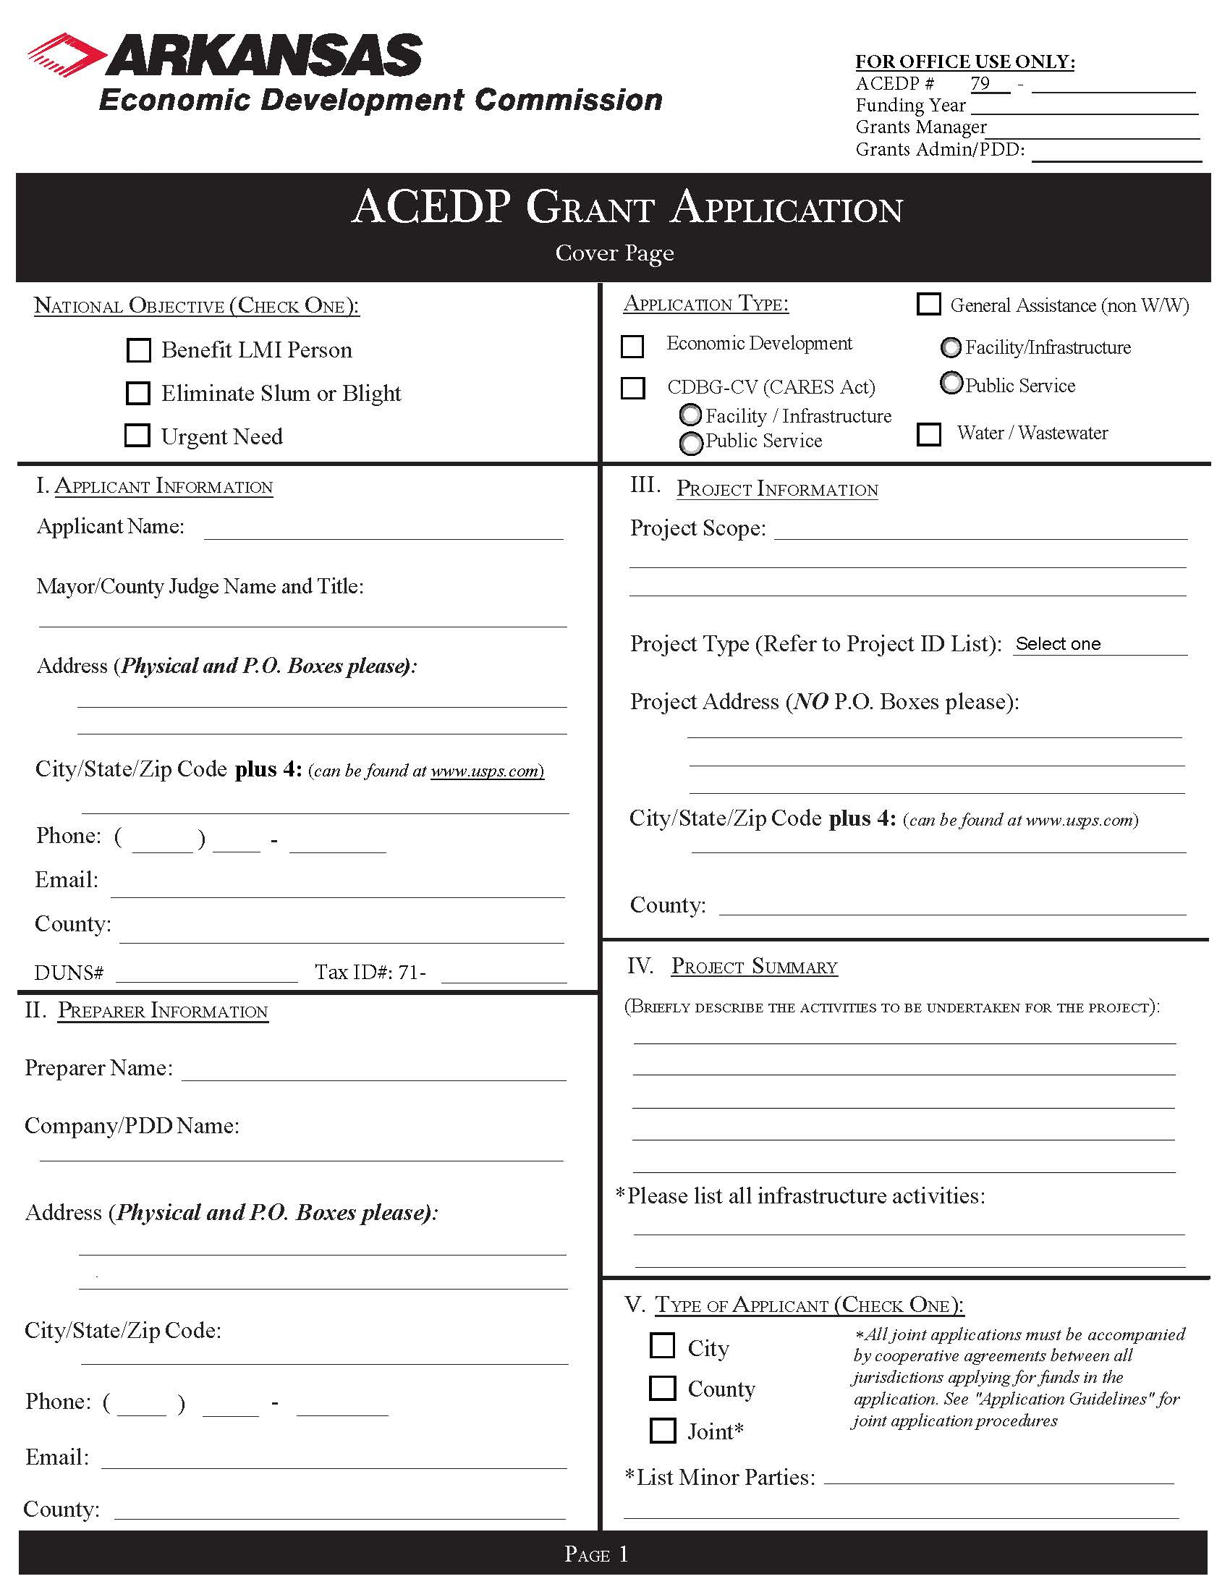

See Part I, General Information
.pdf form online and insert here
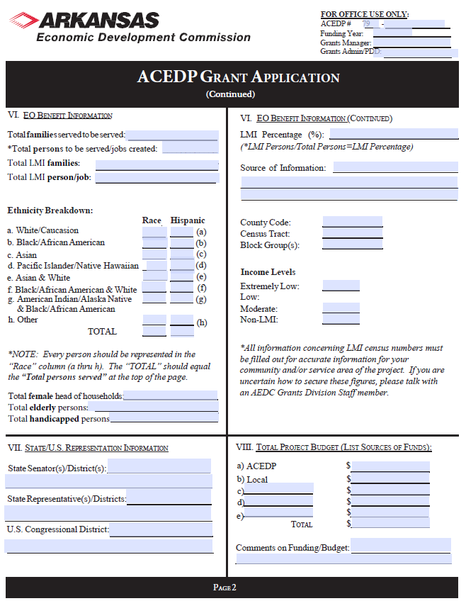

See Part I, General Information
.pdf form online and insert here

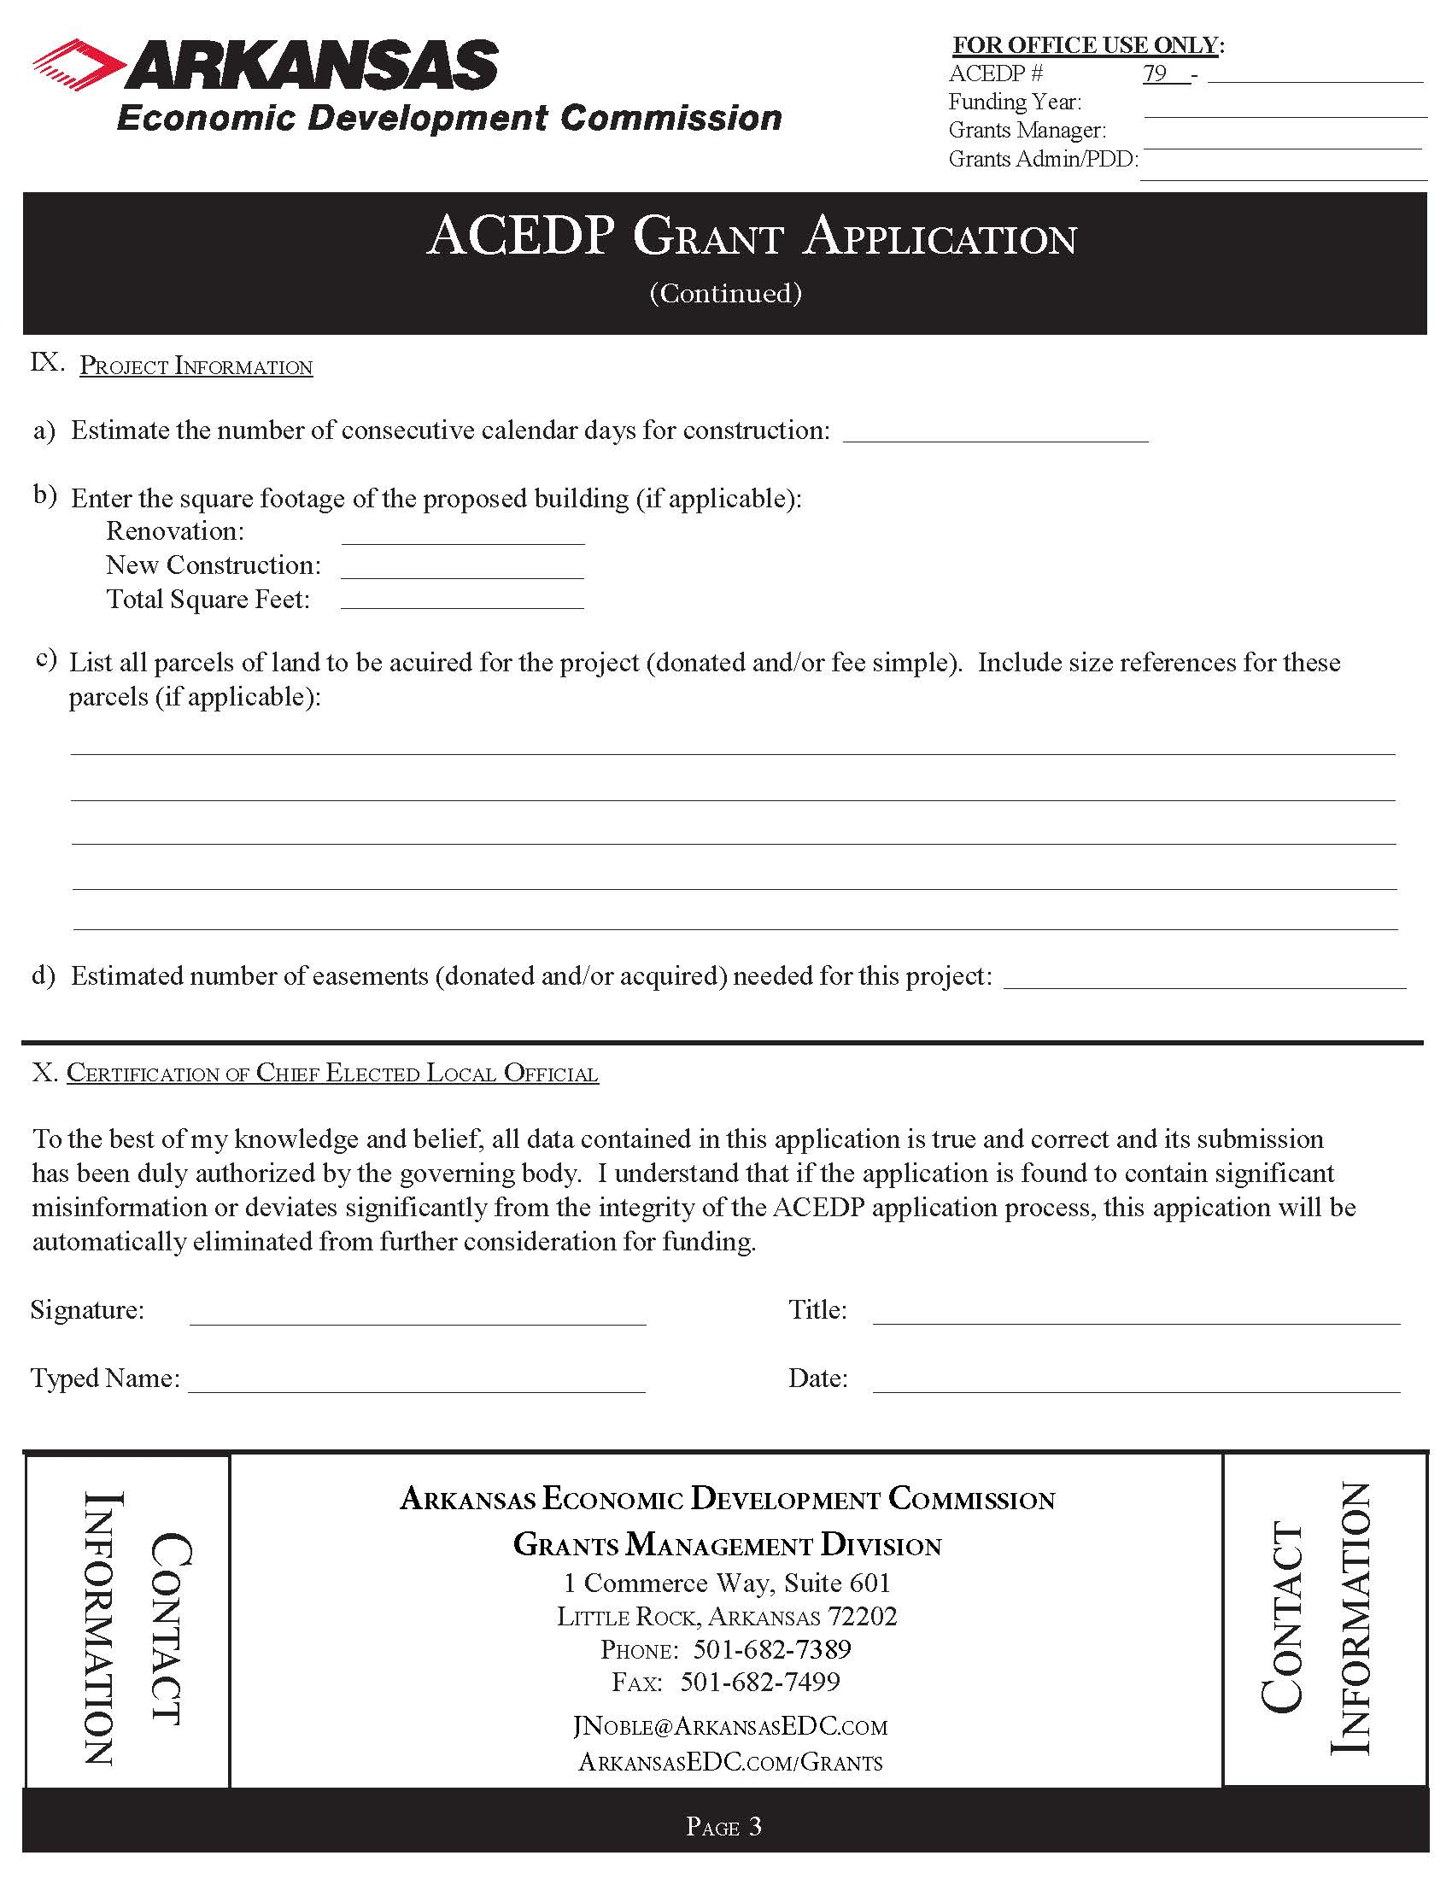

See Part I, General Information
.pdf form online and insert here
Part II. Project Budget

Applicant:
Funding Year: | Grant Year: 2023 | ACEDP Grant Control # :

Description |  | IDIS # |  | Other Funding Sources
Cost Classifications |  |  | CDBG | Local Cash |  |  | Total
Acquisition (attach itemized list)
Land |  |  |  |  |  |  | $ 0.00
Abstractor |  |  |  |  |  |  | $ 0.00
Appraiser |  |  |  |  |  |  | $ 0.00
Legal |  |  |  |  |  |  | $ 0.00
Survey |  |  |  |  |  |  | $ 0.00
Architectural/Engineering: Basic Fee |  |  |  |  |  |  | $ 0.00
Inspection |  |  |  |  |  |  | $ 0.00
Additional Services (attach list) |  |  |  |  |  |  | $ 0.00
Construction |  |  |  |  |  |  | $ 0.00
Construction Contingency (maximum of 5%) |  |  |  |  |  |  | $ 0.00
Equipment |  |  |  |  |  |  | $ 0.00
LMI Hookups |  |  |  |  |  |  | $ 0.00
M & O |  |  |  |  |  |  | $ 0.00
Other |  |  |  |  |  |  | $ 0.00
Fees |  |  |  |  |  |  | $ 0.00
Permits |  |  |  |  |  |  | $ 0.00
Testing |  |  |  |  |  |  | $ 0.00
Other (specify__________________________) |  |  |  |  |  |  | $ 0.00
 |  |  |  |  |  |  | $ 0.00
 |  |  |  |  |  |  | $ 0.00
 |  |  |  |  |  |  | $ 0.00
Subtotal (A) |  |  | 0.00 | 0.00 | 0.00 | 0.00 | $ 0.00
Description |  | IDIS # |  | Other Funding Sources
Administration |  |  | CDBG |  |  |  | Total
Contractual |  |  |  |  |  |  | $ 0.00
General |  |  |  |  |  |  | $ 0.00
Audit |  |  |  |  |  |  | $ 0.00
Subtotal (B) |  |  | $0.00 | $0.00 | $0.00 | $0.00 | $ 0.00

Grand Total (A + B) | $0.00 | $0.00 | $0.00 | $0.00 | $ 0.00

Part II INSTRUCTIONS
FOR COMPLETING THE PROPOSED BUDGET

FOR ACEDP PROJECTS

Although some costs may not be definite at the time of budget preparation, it is important that the Proposed ACEDP Application Budget contains comprehensive, up-to-date cost estimates. These estimates can then be used to negotiate final budget amounts.

Project Information

Enter the name of the City or County as Applicant and the Control Number assigned to the project by the Commission.

Cost Classifications Guidance

All acquisition costs must be accompanied by a brief discussion of each service to be provided and justification of the necessity of the services, including cost estimates. Each acquisition cost must indicate the unit rate and estimated number of units.

No ACEDP funds shall be used for Legal Services except for condemnation.

If ACEDP funds are requested for professional design services, the following fee scales must be utilized:
- Engineering costs must be in accordance with the USDA-RD engineering service fee schedule.
- Architectural costs must be in accordance with the State Building Services fee schedule.
If needed, these scales can be requested from the Commission at 682-1211.

Detailed explanation and justification, including calculation of cost, must be provided for any additional engineering services requested. Usually, no additional services will be approved.

Contingency funds may be Construction Contingency funds only, and are limited to 5% of the total construction cost
For LMI Hookup costs, use $1,500 per hookup times the total number of LMI households reported. Do NOT adjust the figures to compensate for any percentage of anticipated hookups.

Any funds requested for "Other" must include a discussion of the requested service, including justification and cost calculations.

Include all grants and loans for which the Applicant has applied. Contact the ACEDP Program Manager for required documentation, which varies on a case-by-case basis. Offered financing may be greater or less than requested amounts. The importance of providing this financial information to the Commission and other funding partners is so grants of appropriate size may be offered.
Do not include administrative costs on this budget estimate. These costs will be calculated by the Grants Division and added to the grant budget.

Part III. Project Description & Scoring Criteria

The Matrix below describes each selection criteria as a numerical score within the General Assistance Program. The maximum number of points available within any application is 100 points. All selection criteria will be scored in five-point increments and shall be scored on a scale.

(1) | (2) |  | (3) | (4) | (4) | (5) | (6)
Project Need |  | Project Specs | Project  Readiness | Cost  Effectiveness | Citizen Participation | Leveraging | LMI  Benefit | TOTAL
30 |  | 10 | 30 | 10 | 10 | 5 | 5 | 100 points

Limit responses to the space provided below with a minimum 9-point font (Arial or Calibri). For each of the following sections a project narrative must be provided and any additional information as noted within each individual application question.
Item 1: PROJECT NEED: Up to 30 points possible. The level of project need will be compared to other applicants.

Points in this section include:

0-9 points—no clearly defined problem or no clear description of the need for the project.

10-19 points—minor problems or minor need are only defined.

20-30 points—major problems or description of project need is clearly defined.

Some examples of major needs include:
- Water infiltration and inflow or decrepit distribution lines;
- Wastewater collection system components need to be replaced or rehabilitated;
- Significant structural problems within the public utility;
- There is a health and safety threat to users;
- The conditions developed or became urgent within 18 months of the date the proposal is submitted;
- The applicant locality is unable to finance the project on its own, no other funding is available to address the problem, and the CDBG funding will be directly targeted towards alleviation of the threatening conditions;
- An urgent threat supported by either:
  - A current declaration of an emergency by the Governor of Arkansas relative to a flood, a hurricane, a tornado, an earthquake, or other disaster event, not including droughts, snow, or ice conditions; or,
- A current declaration of an immediate and severe health threat by the Arkansas Department of Health or Arkansas Department of Environmental Quality relative to the complete failure of a public water or sewer system or incident of similar significance.
The application narrative shall be scored for: (a) explanations of the overall purpose of the project application and factual information that illustrates the severity of the problems or needs; (b) past efforts to resolve the problem and meet the local needs; and (c) stated goals and objectives for resolving the problem or need.

Problems that are generally attributable to a lack of routine maintenance result in a less favorable evaluation.

Item 2: PROJECT SPECIFICATIONS: 10 points maximum possible. Describe the technical and financial specifications of the project and provide clarity on how the project will benefit those identified by a CDBG National Objective. The significance of the project specifications will be scored as compared to other applicants.

Points in this section include:

0-2 points—inadequately defined specifications.

3-5 points—reasonably defined specifications that is average compared to other applicants.

6-10 points—above average description of project specifications. All requested data provided.

The proposed solution must completely remedy the existing problems which pose a serious and immediate threat to the health and welfare of the community, if applicable (see above).
Within this section, the applicant should explain the technical and financial aspects of the project. Projects should have a clear outline of activities, state who will be responsible for each activity, and provide detailed financial information related to the project.

Item 3: PROJECT READINESS: Up to 30 points possible. The level of capacity and commitment by the community will be scored as compared to other applicants.

Points in this section will include:

0-9 points—lack of local staff or ability to oversee the efforts from planning to the implementation of the physical project, no availability of the site(s) investigated, preliminary work is not substantially completed, and project is not construction ready.

10-19 points—local capacity is demonstrated through past projects, past community improvement efforts, citizen participation, there is strong evidence of a commitment to proceed with the project, the feasibility and cost estimates are reliable, the project is construction ready and financial resources have been investigated.

20-30—Significant local capacity demonstrated through past improvement efforts, financial resources are secured and pending CDBG award approval, match/non-CDBG funding is committed and documented, and environmental review has been completed.

Item 4: COST EFFECTIVENESS: Up to 10 points possible. The cost per persons benefitting will be calculated for each project.

Cost effectiveness scoring will be determined first by separating all applications into two population groups. The grouping of applications is based on the average number of total persons benefitting which is computed by dividing the sum of the total persons benefitting by the number of applications received. One group is based on the larger than average number of beneficiaries and the other group is based on the average number and smaller than average number of beneficiaries. The application in each group having the best cost effectiveness (cost per person) receives 10 points and the remaining application are prorated.

Item 5: Citizen Participation: Up to 10 points possible. Applicant’s description of public participation and the process used to identify community needs and allocate resources to address needs will be compared to other applicants.

The following criteria will be taken into consideration when determining the community’s score for the Citizen Participation section.
- Completed a comprehensive needs assessment;
- The needs assessment process includes documented citizen participation;
- Developed, distributed, and analyzed a community needs surveys;
- Held public meetings to discuss the outcomes on the community needs analysis;
- Documentation showing the community needs assessment took place within the past 3 years;
- Developed a priority list using the community needs assessment process;
- Developed a strategy to address items in order of the communities priority list;
- A record of conducting other community and economic development efforts with significant citizen involvement within the last three years that address items ranked on the communities priority list;
- The community has adopted or updated a comprehensive plan, housing study, and/or a capital improvement plan within the last five years;
- The community can show evidence of economic initiatives such as completing a business retention and expansion survey, or other viable fundraising efforts.

Points in this section include:

0-2 points—has not completed a majority of the above criteria.

3-5—has completed a majority of the above criteria.

6-10—has completed and properly documented most or all of the above criteria.

Item 6: FUNDING LEVERAGE: Up to 5 points is possible. For purposes of General Assistance applications, leverage is defined as local funds provided by the community committed to the project’s non-administrative activities as a ratio to the grant funds requested.

Points will be awarded to applicants based on the amount of leverage provided in ratio to the grant funds requested. Communities who provide more leverage will receive points within this section. The table below further describes these criteria
 | Leverage
5 points |  | More than 100% match to the grant amount requested
4 points |  | 75-100% of total project costs above grant amount requested
3 points |  | 50-74% match to amount of CDBG funds requested
2 points |  | 30-49% match to amount of CDBG funds requested
1 points |  | 4-29% match to amount of CDBG funds requested
0 points |  | 0-3% match to amount of CDBG funds requested

Item 7: LMI Benefit: Up to 5 points is possible. This scoring category is designed to give points to communities with higher concentrations of LMI persons. Communities with a LMI population of 60% or more will receive 5 points. Communities with a LMI population between 51% - 59.99% will receive no points in this section.

**All project scoring is subject to AEDC Executive Director discretion**

Based on the instructions and information above, below are the questions that will need to be answered for the General Assistance application. Answers should be provided within the boxes noted below, but if necessary, attach additional sheets and documentation as needed.

Application Questions and Scoring Criteria
Item 1. Project Need. (30 points max.) *Note: if this information can be cross-referenced to the Preliminary Engineering Report, please indicate and attach, noting any updates to the PER since most up-to-date submission to the WWAC.
Describe the geographical target area of the project (include entire area served by activity).
Need for the project. Address each of the following: 1) existing conditions, 2) severity, extent, frequency, duration of problem(s), 3) lack of adequate service and distance to comparable service, 4) age and structural deterioration, 5) lack of capacity and functions that cannot be performed, and, 6) health and safety concerns. List any ADH or ADEQ violations. Attach only relevant pages of any mandates, studies or reports, petitions, community assessments or surveys, photos, etc., that identify the proposed project as a need.
Item 2. Project Specifications. (10 points max) *Note: if this information can be cross-referenced to the Preliminary Engineering Report, please indicate and attach, noting any updates to the PER since most up-to-date submission to the WWAC.
Describe each major activity and identify who will own, operate and maintain the proposed improvements. If applicable, provide linear or square feet of project and the design life expectancy of the project. Provide information and supporting documentation identifying the number of residential users; projected monthly residential rate; debt service portion of the rate; operation and maintenance portion of the rate, and identify if the water system is metered. If not, will the water system be metered as part of the project? Also, include maps that identify the boundaries of the applicant’s jurisdiction, boundaries of the project service area, specific location of each activity, and areas within the 100-year flood hazard boundary.

Describe the level of community/business support for the project and potential other investment in area.
Item 3. Project Readiness. (30 points max) *Note: if this information can be cross-referenced to the Preliminary Engineering Report, please indicate and attach, noting any updates to the PER since most up-to-date submission to the WWAC.
Describe the organization that will own and operate the facility. (If other than local government, also specify the organization’s legal status and date of incorporation).
List key individuals who will be responsible for the day-to-day operations and provide specific information regarding their experience and ability.
Identify annual costs, specific revenue events/sources and amounts to demonstrate short- and long-term operation and maintenance. Provide current numeric data.
Address each of the following in order: 1) need identification, 2) alternatives considered and why rejected, 3) preliminary design, 4) determination and maintenance of historic integrity, 5) consultation on environmental impacts, 6) how cost estimates were determined, and 7) status of necessary agreements or permits to implement or construct project, etc.
List each source and amount of other funds to complete the project. For each source, provide 1) name and telephone number of a contact person, and 2) status of the commitment. Attach commitment letters for all listed sources and label as “Attachment 4”.
List other funds investigated and why not available for this project.

Benchmarks. Provide a proposed date for each measurable benchmark in order to outline a schedule for the project. If benchmarks are not met, AEDC may invoke the right to terminate the CDBG contract. The following list is not exhaustive; please add benchmarks applicable to the project on a separate sheet of paper if needed.

Benchmark | Completion Date
Administrative Services Secured
Engineering Services Secured
Environmental Review Complete
Receive RROF approval
Acquisition Complete
Plans/Specifications Submitted
Permits Obtained
Approvals Obtained
Advertisement for Bids
Bid Opening
Contract Awarded
Construction Complete

Item 4. Cost Effectiveness (10 points max)
Up to 10 points is possible, determined by the review team.
Instructions
If the project is a rehabilitation project, or extension to an existing water or sewer line, list the number of customers currently hooked to the system.
List the number of expected new customers. Consider only the unsewered or private water supply households.
Customers do NOT include:
- Businesses
- Schools or other public facilities
- Churches
- Vacant lots
- Vacant residences
List the number of low- and moderate-income families as determined by 100% survey, random sample survey, or official US Census data. The number of moderate-income residences listed here must agree with the data presented on the LMI Worksheet (Exhibit G-1 or G-2), if used.
List the number of non-LMI families as determined by 100% survey, random sample survey, or official US Census data. The number of non-LMI residences listed here must agree with the data presented on the Exhibit G-1 or G-2, if used.
Note: Non-responses to the survey will be counted as non-LMI households in calculations, but should be reported as “non-responses” on the LMI Worksheets. Vacant, inhabitable residences will also be counted as non-LMI households in calculations, but should be listed as “vacant residences” on the LMI Worksheet (Exhibit G-1 or G-2) and on the ACEDP Grant Application Form.
Income Survey Methodology and full instructions on completing a valid, methodically sound income survey is provided at www.arkansasedc.com/grants

Existing Customers: |  | Expected New Customers: (if any)
LMI Families: |  | LMI Families:
Non-LMI Families: |  | Non-LMI Families:
Total Project Customers:

Cost per customer: $_____________ (total construction amount/total customers)

Please Note! We are not asking for the “user cost”/residential rate here

Item 5. Citizen Participation (10 points max available)
Public Participation Process. Provide information for the past 5 years on each the following: 1) extent of “public” involvement; 2) identification of community needs; 3) how community has addressed needs identified in item 1; 4) how community has allocated resources towards priority needs. Attach additional information as needed. Be sure to include dates. (10 points maximum)
Did the public participation process include:
Developing and distributing community attitude surveys? |  | YesNo | Dates:
Public meetings to develop community priorities? |  | YesNo | Dates:
Involving local groups/organizations to develop community priorities? |  | YesNo
Prioritization of survey results? |  | YesNo
Developing action plans for short & long term projects? |  | YesNo
List community and economic development efforts with citizen participation that have been conducted within the past 3-5 years as a result of the above efforts. Please include dates. Attach additional pages if needed.
List all projects/programs implemented/completed within the past 3-5 years. Please include dates. Attach additional pages if needed.
Please list the update or adoption dates of:
Comprehensive plan | ___________________________ Not Applicable_________________
Housing study | ___________________________ Not Applicable__________________
Capital improvement plan | ___________________________ Not Applicable__________________
Has your community completed a business retention and expansion survey for the community? |  |  |  | YesNo
Completion Date:_____________________________

Item 6. Leveraging
Up to 5 points possible. For purposes of General Assistance applications, leverage is defined as local funds provided by the community committed to the project’s non-administrative activities as a ratio to the grant funds requested. AEDC encourages local (or other) funds to be used for all engineering services, and administrative costs.

Points will be awarded to applicants based on the amount of leverage provided in ratio to the grant funds requested. Communities who provide more leverage will receive points within this section. The table below further describes these criteria.

Leverage
5 points | More than 100% match to the grant amount requested
4 points | 75-100% of total project costs above grant amount requested
3 points | 50-74% match to amount of CDBG funds requested
2 points | 30-49% match to amount of CDBG funds requested
1 points | 4-29% match to amount of CDBG funds requested
0 points | 0-3% match to amount of CDBG funds requested

Item 7. LMI Benefit/National Objective
Up to 5 points is possible. This scoring category is designed to give points to communities with higher concentrations of LMI persons verifiable at the time of application. Communities with a LMI population of 60% or more will receive 5 points. Communities with a LMI population between 51% - 59.99% will receive no points in this section.
Check the appropriate national objective and verification method for each CDBG funded activity (see Application Guidelines, Section 1(A)).

Area Benefit Activities:
Census: Attach HUD census data
*Census data must be taken from the AEDC website at: http://www.arkansasedc.com/grants. Information is found under the headings, “Census LMI Percentages by City or County,” “LMI for Cities and Counties,” or “LMI by Block Group” or Contact the AEDC Grants Division for further information.
Published LMI % _________

Census Tract(s) _____________ Block Group(s)____________ (if using census tract information)

Survey: Complete Exhibit G-1 – LMI Worksheet Census Survey
Survey Completion Date _________

Resulting LMI % _________

Survey: Complete Exhibit G-2 – LMI Worksheet Random Survey
Survey Completion Date _________

Resulting LMI % __________

Income Survey Methodology and full instructions on completing a valid, methodically sound income survey is provided at www.arkansasedc.com/grants

Urgent Need: attach Exhibit J, Urgent Need Certification

PART IV. Exhibits and Attachments

The Exhibits package contains specific information on the Exhibits that are required for the project as well as any necessary Attachments that must also be provided in order for the applicant to submit a complete application.

The list of required exhibits is identified below as well as provided within the Table of Contents Checklist. All Exhibit information and templates will be found in the Exhibits package.

The following Exhibits include the certification and documentation requirements for the General Assistance application. These Exhibits must be submitted with the application.

- Exhibit A: Notice of Public Hearing (including Proof of Publication or Certificate of Posting, attendance roster, and summary of citizen's comments)
- Exhibit B: Authorizing Resolution (Original or Certified copy)
- Exhibit C: Statement of Assurances and Certifications
- Exhibit D: Citizen Participation Plan
- Exhibit E: Residential Anti-displacement and Relocation Assistance Plan
- Exhibit F: Excessive Force Resolution
- Exhibit G-1: LMI Census Worksheet (only for LMI area benefit)
- Exhibit G-2: LMI Random Sample Worksheet (only for LMI area benefit)
- Exhibit H: LMC Worksheet (Limited Clientele)
- Exhibit I-1: Slum and Blight Area Basis Documentation (for SBA projects)
- Exhibit I-2: Slum and Blight Spot Basis Documentation (for SBA projects)
- Exhibit J: Urgent Need Certification (for Urgent Need projects)
- Exhibit K: FFATA Federal Funding Accountability and Transparency Act
- Exhibit L: Map of Proposed Project Area
- Exhibit M: Systems for Award Management (SAM) record and clearance documentation
- Exhibit N-1: Four Factor Analysis Assessing Limited English Proficiency
- Exhibit N-2: Language Assistance Plan (optional at the time of application)

The following attachments are required for General Assistance WW Applications:
Attachment 1: WWAC Recommendation Letter

Attachment 2: Up-to-date cost estimates for all costs listed in Part II, Project Budget

Attachment 3: Commitment letters for all sources listed in Part II, Project Budget

Attachment 4: Preliminary Engineering Report

Any additional attachments that are provided within the application should be appropriately labeled and noted as the information provided within the Table of Contents Checklist.

Section C. Water/Wastewater Advisory Committee (WWAC) Process
The WWAC was implemented in 1992 and received national recognition as a unique model because of the cooperative efforts of the funding and regulatory agencies involved. Four state agencies partner in support of water and wastewater services. The WWAC provides project development guidance and recommends project financing to communities through its application process.
How often does the committee meet and for what purpose?
Representatives from the member agencies meet the first Wednesday of each month to review pre-applications for water/wastewater projects. The WWAC meetings are open to the public, and potential applicants may attend the meetings. Projects have to be submitted to the Arkansas Department of Agriculture’s Natural Resources Division by the 15th of a month to make the agenda for the next meeting.
Who are the partners?
- Arkansas Natural Resources Commission
- Arkansas Department of Health
- Arkansas Department of Environmental Quality
- Arkansas Economic Development Commission
- U.S. Department of Agriculture - Rural Development
- Communities Unlimited
What types of projects can be funded?
- Treatment Plants
- Distribution Lines
- Collection Lines
- Water and/or Wastewater Service Extensions
- Elevated or Ground Storage Tanks
- New Water Sources - Wells, Other Systems, etc.

What are the sources of funds used to fund Water and Wastewater projects?
The Natural Resources Division administers two Federal and three State programs which provide financial assistance through loans and grants to Arkansas entities for water and wastewater projects. Funds can be used for new or existing systems. Please contact Debra Dickson at (501) 682-0548 for information on the programs available through the Natural Resources Division.
The Arkansas Economic Development Commission administers the funds from the State Community Development Block Grant (CDBG) program used for Water and Wastewater projects. Non-entitlement cities and counties are eligible to apply for these State CDBG funds. Projects funded must certify that at least 51 percent of the households served are low or moderate income, based upon the HUD Section 8 income limits. Please contact Jean Noble, the Director of the Grants Management Division, at (501) 682-7389 for more information about the State CDBG water and wastewater grant program.
The United States Department of Agriculture Rural Development awards loan and grant funds to entities. Funds can be used for new or existing systems. Please contact David Kircher at (501) 301-3265 or Alan Johnson at (501) 301-3270 for more information on the USDA - Rural Development programs.
Communities Unlimited assists entities in the successful operation and maintenance of water/wastewater systems as well as short-term financing. Please contact Tonya Kendrix at (501) 291-9229 for more information about their funding and technical assistance programs.
What has to be submitted to the Water/Wastewater Advisory Committee?
The WWAC Pre-Application Form must be submitted. A preliminary engineering report is not required but may be requested by the committee. The Water/Wastewater Advisory Committee has developed a single pre-application form for both Water projects and Wastewater Projects.
How long does this process take?
Typically, the review of a project will take a month. However, if the information submitted is not complete or the agencies reviewing the information have questions, the Committee will send out a comment letter asking for additional information. Once each agency is satisfied, the Committee will provide a recommendation letter listing the potential funding sources for the project. The Committee will not dictate the source of funding that must be used.
The Committee has one pre-application form for both water and wastewater projects:
WWAC Pre-Application Form
To submit a Natural Resources Division funding application, please visit the the Funding Application page:
- Funding Information
For more information contact:
Amy Theriac
Program Outreach Coordinator
Arkansas Department of Agriculture
Natural Resources Division
1 Natural Resources Drive
Little Rock, AR 72205
501 682-0547
Email: AGRI.wwac@agriculture.arkansas.gov

